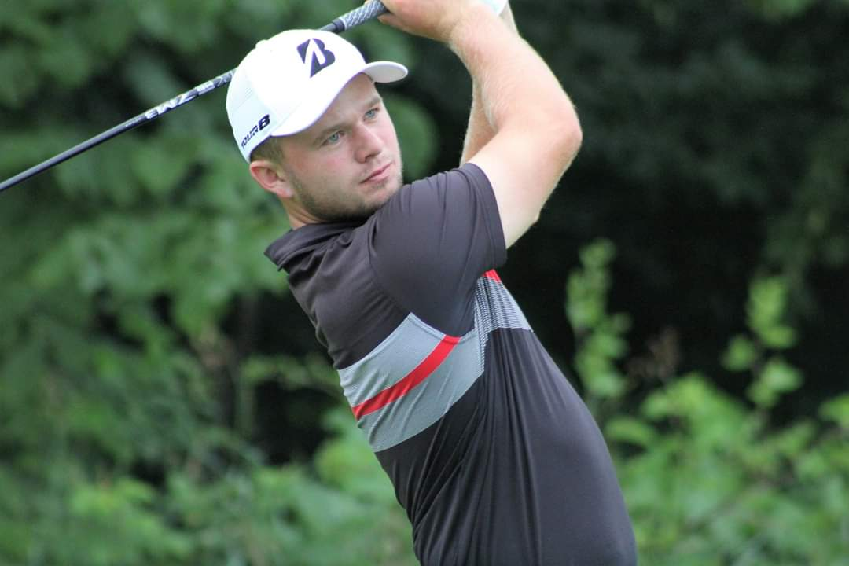
Beau Breault
Contact Information:
beaubreault7@gmail.com

Academic Accomplishments
- Finance Major - GPA of 3.80 – Magna Cum Laude
- 2-time Srixon/Cleveland All-American Scholar
- 2-time All-Academic Mid-American Conference
- 4-time MAC Distinguished Scholar Athlete
- 2019 EMU Medal of Excellence Award

Professional Career (September 2019 – Present)
- 1st/115 Toledo Open @ Stone Oak CC (66-68)
- 1st/31 Moonlight Golf Tour @ ChampionsGate National Course (68)
- 2nd/30 Moonlight Golf Tour @ MetroWest GC (71)
- 2nd/24 Moonlight Golf Tour @ ChampionsGate National Course (66)
- t-3rd/28 Egglands Best Golf Tour @ West Orange CC (68-72-68)
- t-4th/63 Moonlight Golf Tour @ West Orange CC (66)

2018-2019 EMU Senior Year
- Named Mid-American Conference Player of the Year for 2019
- Named First-Team All-Conference
- Set the All-Time single EMU scoring record of 71.67
- Second All-Time in EMU Scoring Average History
- 1st/156 Kent County Invitational @ L.E. Kaufman GC (70-68-72)
- 3rd/162 108th Michigan Amateur @ Oakland Hills North CC (Stroke/Match)

2018 Summer Campaign
- 1st / 46 PGA Midwest Golf & Turf Pro Am @ The Fortress, Frankenmuth, MI
- 1st / 156 107th Annual Michigan Amateur @ Country Club of Detroit (Stroke/Match)
- 3rd / 90 Horton Smith Invitational @ Detroit Golf Club (69-68-73)

2017-18 Highlights (Junior @ EMU)
- t-1st / 66 Dayton Flyer Invitational (WAGR D Field) @ NCR Country Club (72-67-73)
- 2nd / 162 106th Annual Michigan Amateur @ Egypt Valley CC (Stroke/Match)

2015-17 Highlights (Freshman-Sophomore @ EMU)
- t-5th / 90 GCU Invitational- Grand Canyon University GC (72-66-70)
- t-8th / 80 Windon Memorial- (WAGR D Field) @ (72-70-75)

2014-15 Highlights (Senior @ Hartland High School)
- 2nd / 90 AJGA Randy Wise Invitational @ Flint Golf Club (70-69-70)
- 1st / 72 GAM Junior Invitational @ Forest Akers West GC (70-72)

